The Producers of The Panama Deception & COVERUP: Behind the Iran Contra Affair
Present
SOLDIERS SPEAK OUT
Please join Academy Award Winning Director, Barbara Trent
Reverend Janet McKeithen
Blase Bonpane – Office of the Americas
Abdul Henderson – Iraq Veterans Against the War
More speakers to be announced !1
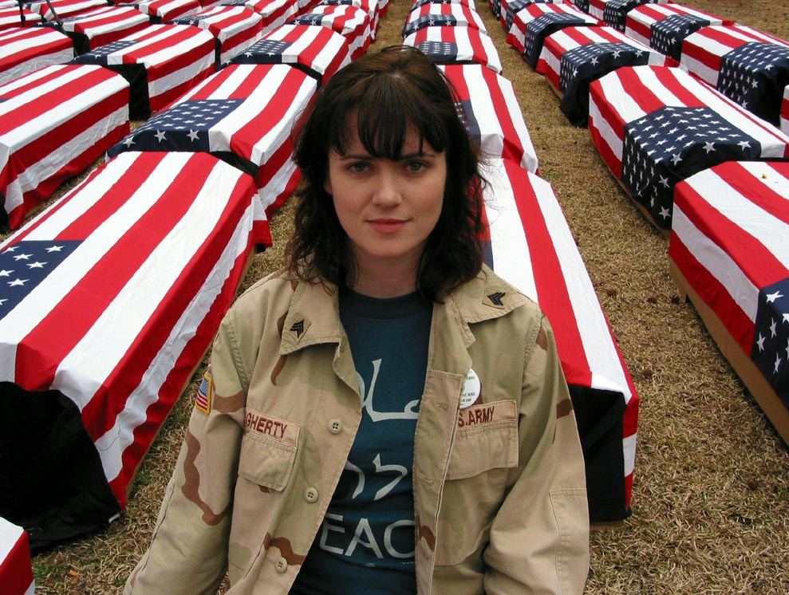
Kelly Dougherty, Iraq Veterans Against the War. Photo by Silke Mayer

For a Fundraiser and Release Screening of Empowerment Project’s new Documentary.
“SOLDIERS SPEAK OUT” gives a loudspeaker to the courageous anti-war and anti-occupation movement within the military and their families. This 20 minute DVD will serve as a counter-recruitment and organizing tool for activists, schools, and organizations.

Tuesday, November 15th
6:30 PM reception & refreshments
7:30 PM presentation & screening
Music by Tina Karras & Andy Manoff
The Church in Ocean Park, 235 Hill St., Santa Monica, CA 90405
$15 donation requested (all donations will support the distribution campaign)
RSVP: (310) 399-1631
For more information, visit www.empowermentproject.org or call: Ben Swets (310) 581-6772
Sponsored by: The Church at Ocean Park, Transvision, and Empowerment Project

This film has been made possible through the support of:
+ TopangaPeaceAlliance.org + FriendsOfFilm.com + Citizens for Peaceful Resolutions + CaliforniaPeaceAction.org
+ Global Exchange Supporters of Ventura County + VeteransForPeace.org + AMOR alternative2military.tripod.com
+ Iraq Veterans Against the War IVAW.net + AddictedToWar.com + NoMoreVictims.org
+ CAMS Coalition Against Militarism in Our Schools + Gold Star Families for Peace gsfp.org + ArlingtonWestFilm.com + OfficeoftheAmericas.org + FromTheHeartProductions.com + TopangaGreens.org + Another World View Is Possible
+ USLAW USLaborAgainstWar.org + United Teachers Los Angeles UTLA.net
+ PDSMM Progressive Democrats of the Santa Monica Mountains + ANSWER Ventura Co answervc@riseup.net
+ Palisadians for Peace PalForPeace@aol.com

