Come See Academy Award Winning Director
and Independent Filmmaker Barbara Trent
at Two Free Events Open to the Public

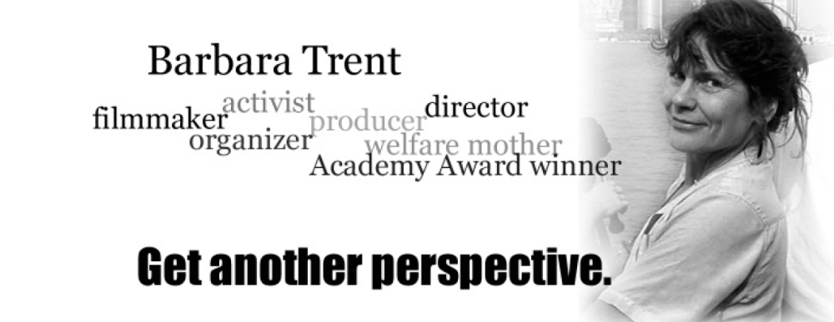

Tuesday, September 12

7p.m., 113 Carnegie Building

“THE SEARCH FOR TRUTH:
The Responsibility of the Media, the Government,
and the American Public”

Presentation of her Academy Award winning documentary, The Panama Deception, and discussion. The Panama Deception reveals the untold story of the U.S. invasion, the shocking events of the assault, and the true motivation for the invasion, explaining how and why the mainstream media collaborated with the U.S. government to censor information and deceive the public.

Wednesday, September 13

12:15 p.m. (BYO lunch); 12:40 p.m. (presentation)
102 Kern Building
Comparative Literature Lunch Presentation

“The Economics of Media Censorship”

Drawing from over fifteen years as a filmmaker, Barbara Trent walks her audience through the obstacles to a courageous and independent media with anecdotes drawn from her own experience producing, directing, and distributing three controversial and award-winning feature documentaries.

This visit is sponsored by Comparative Literature; Film-Video and Media Studies; Journalism; Latin American Studies; the Rock Ethics Institute; and by Spanish, Italian and Portuguese.

Barbara Trent's appearance was made possible by The Academy of Motion Picture Arts and Sciences Visiting Artists Program. | 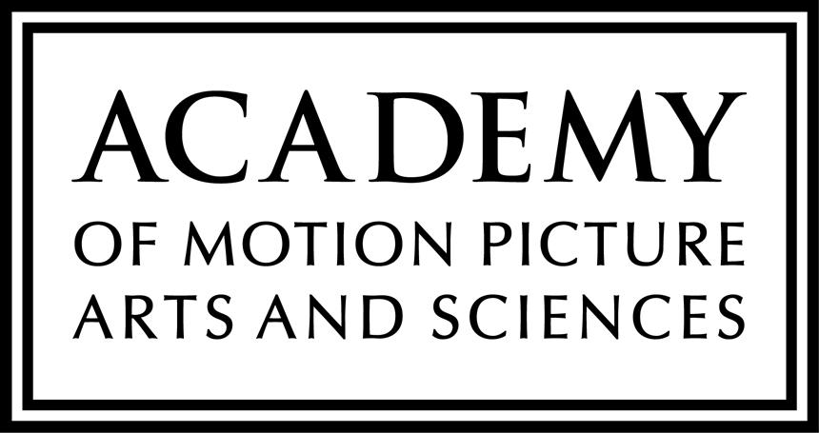

Penn State is committed to affirmative action, equal opportunity, and the diversity of its workforce.
Penn State encourages qualified persons with disabilities to participate in its programs and activities. If you anticipate needing any type of accommodation or have questions about the physical access provided, please consult Cindy Bierly 863-0589 in advance of your participation or visit. U.Ed. LBA 07-31
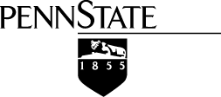
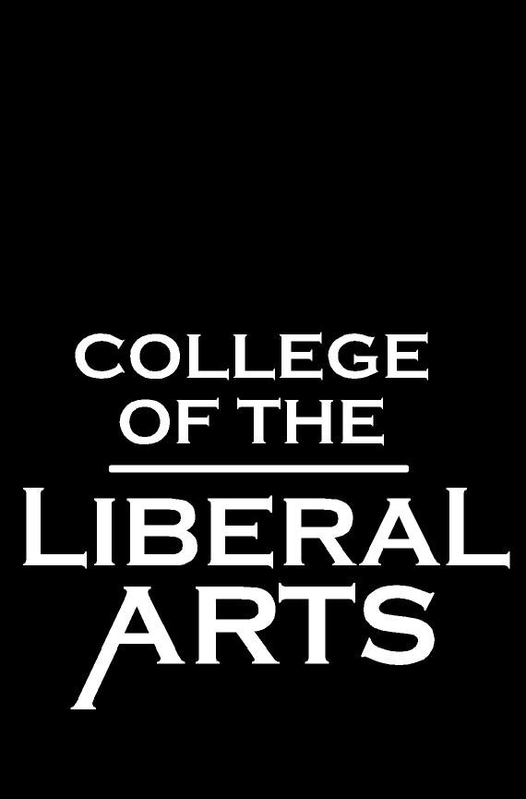This Publication is available in alternative media on request.



